Task 1
Create one Jenkins job using the below code and create three stages:
- stage1: Git clone to download the source code.
- stage2: Sonarqube Integration to check the quality of code.
- stage3: Slack Integration to send the alerts to slack.
URL: https://github.com/betawins/VProfile-1.git

There are 6 stages in CI/CD :-
stage1: Git clone to download the source code.
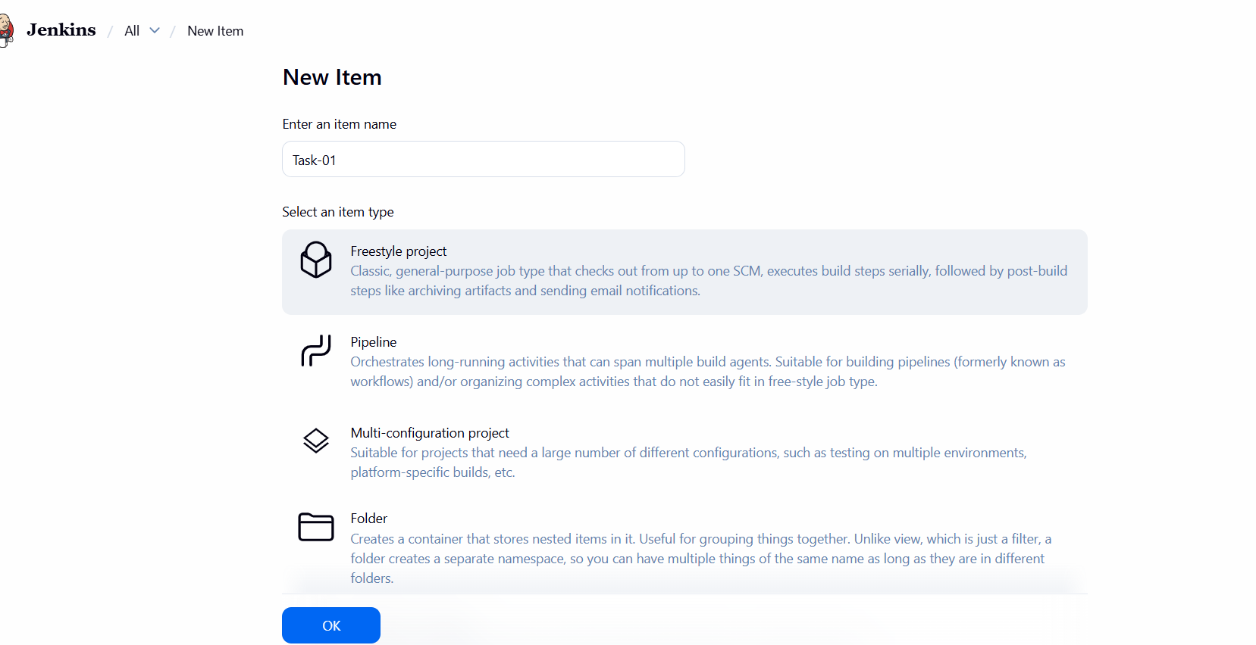
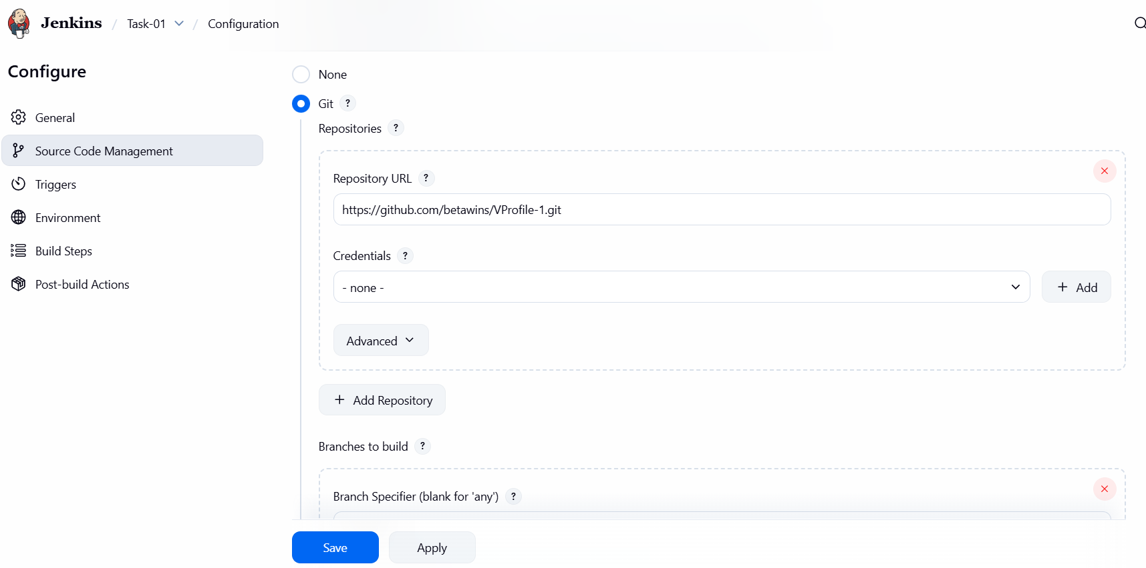
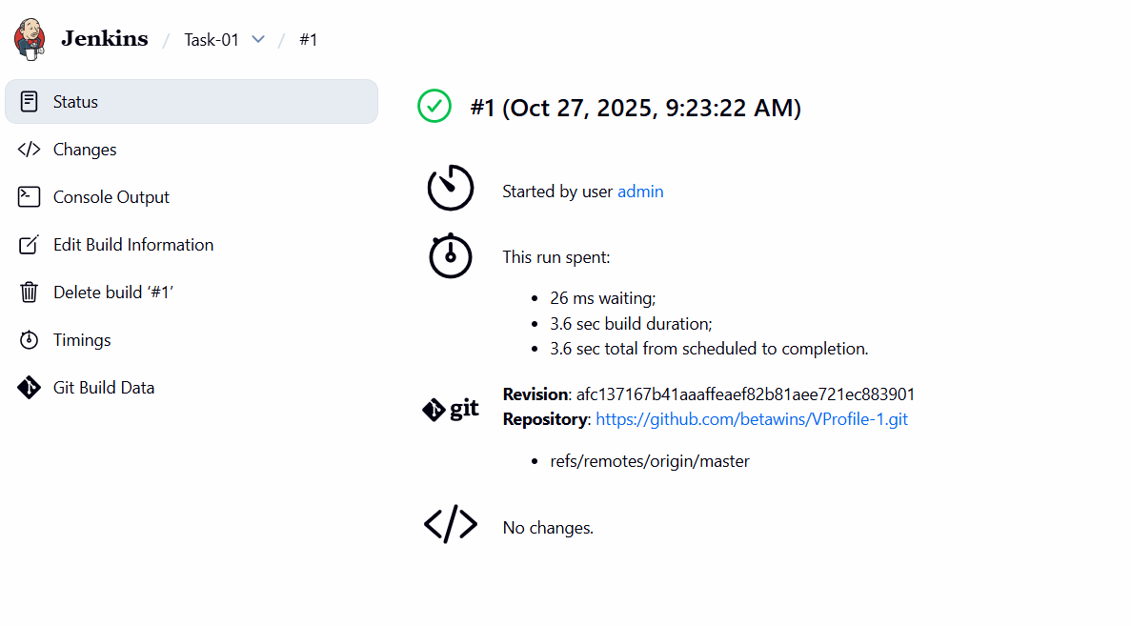
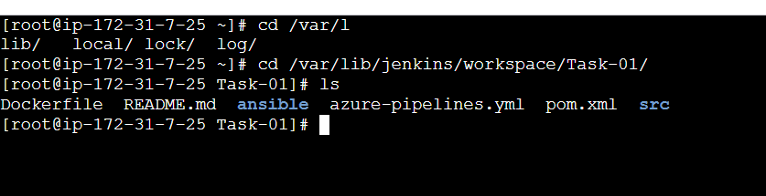
stage2: Sonarqube Integration to check the quality of code.
# SonarQube Installation
SonarQube provides the capability to not only show health of an application but also to highlight issues newly introduced. With a Quality Gate in place, you can fix the leak and therefore improve code quality systematically.
#Prerequisites
1. EC2 instance with Java 1.8 installed [yum install java-1.8*]
2. Use t2.large with at least 20gb memory to run sonarqube.
3. MySQL Database Server or MySQL RDS instance.
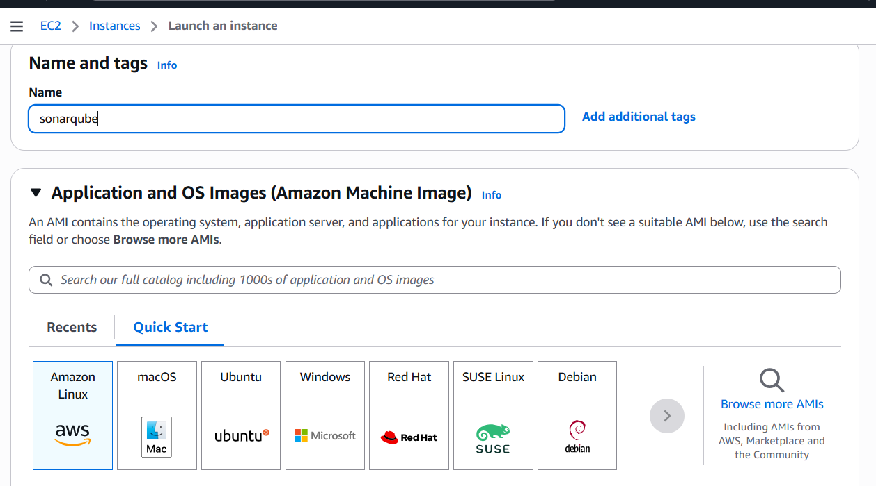
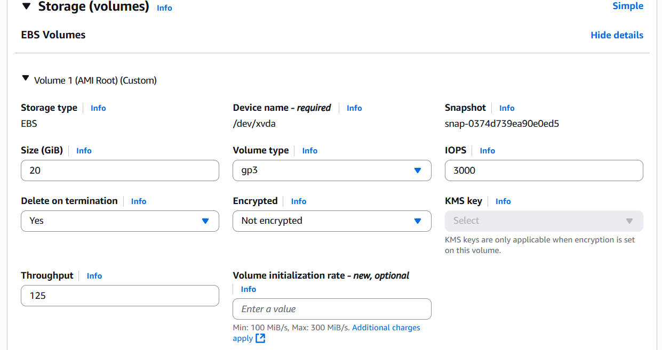
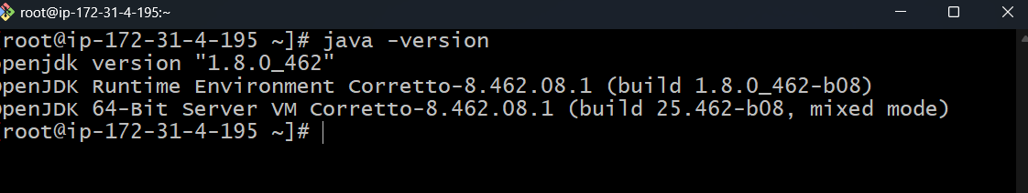
Add mysql rpm Repository:-
- yum update
- sudo wget https://dev.mysql.com/get/mysql57-community-release-el7-11.noarch.rpm
- sudo yum localinstall mysql57-community-release-el7-11.noarch.rpm
- rpm --import https://repo.mysql.com/RPM-GPG-KEY-mysql-2022
- sudo yum install mysql-community-server
- sudo systemctl start mysqld.service
- sudo systemctl status mysqld.service
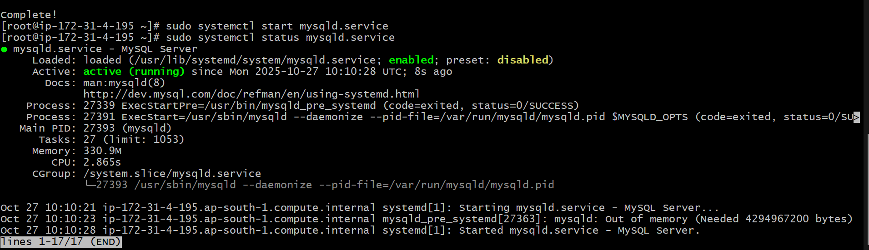
Configure the MySQL Root Password you will see default MySQL root password
grep 'temporary' /var/log/mysqld.log
!E2mwHsN=w?q
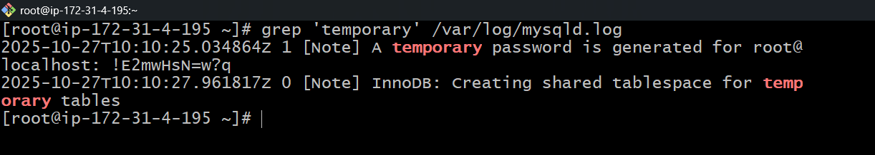
Login to mysql using the default password
mysql -u root -p
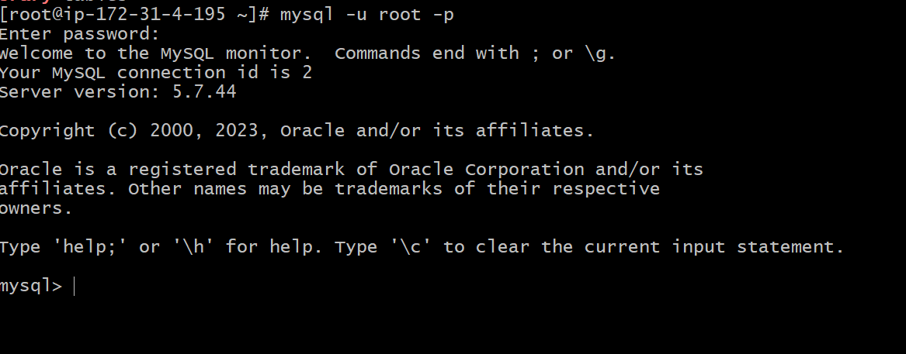
Now replace the default password with a new and strong password
- ALTER USER 'root'@'localhost' IDENTIFIED BY 'Admin@123';
- flush privileges;
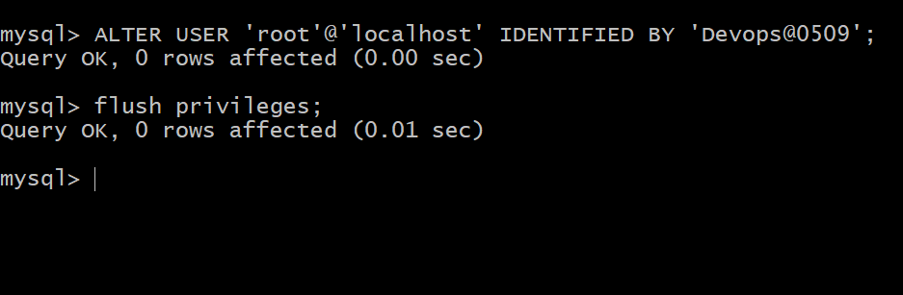
Exit from mysql and Test Using new password Devops@0509.
mysql -u root -p
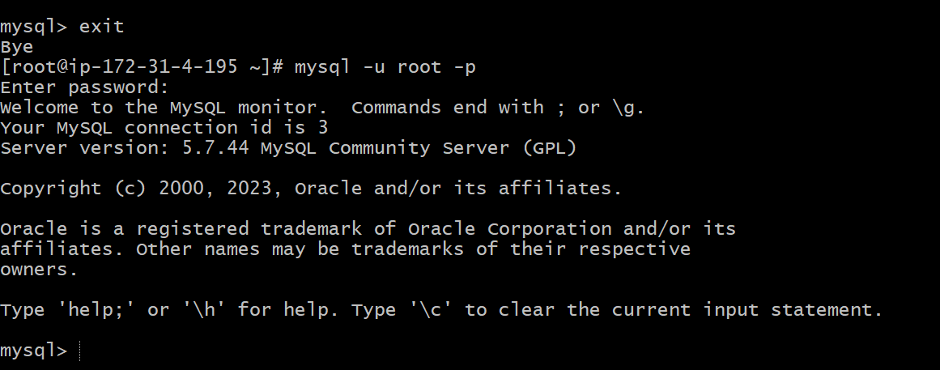
Download stable SonarQube version from below website.
Website: https://www.sonarqube.org/downloads/
Note: This Article written for SonarQube6.0

Download & unzip SonarQube 6.0
# cd /opt
# wget https://binaries.sonarsource.com/Distribution/sonarqube/sonarqube-6.6.zip
# unzip sonarqube-6.6.zip
# mv /opt/sonarqube-6.6 /opt/sonar
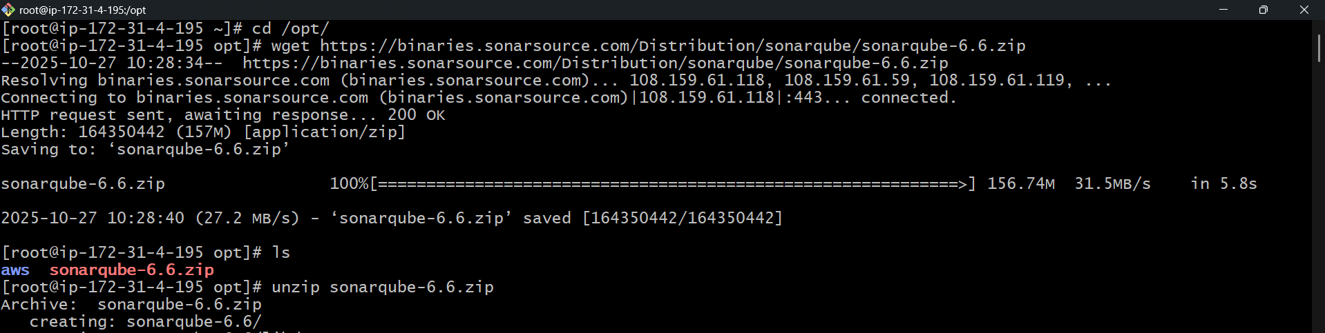
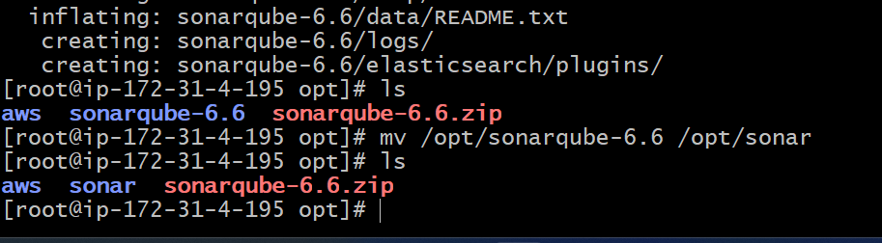
Login to mysql:-
mysql -u root -p

Create a new sonar database:-
CREATE DATABASE sonar CHARACTER SET utf8 COLLATE utf8_general_ci;

Create a local and a remote user:-
CREATE USER sonar@localhost IDENTIFIED BY 'Sonar@123';
CREATE USER sonar@'%' IDENTIFIED BY 'Sonar@123';

Grant database access permissions to users:-
GRANT ALL ON sonar.* TO sonar@localhost;
GRANT ALL ON sonar.* TO sonar@'%';

check users and databases:-
show databases;
SELECT User FROM mysql.user;

FLUSH PRIVILEGES;
QUIT
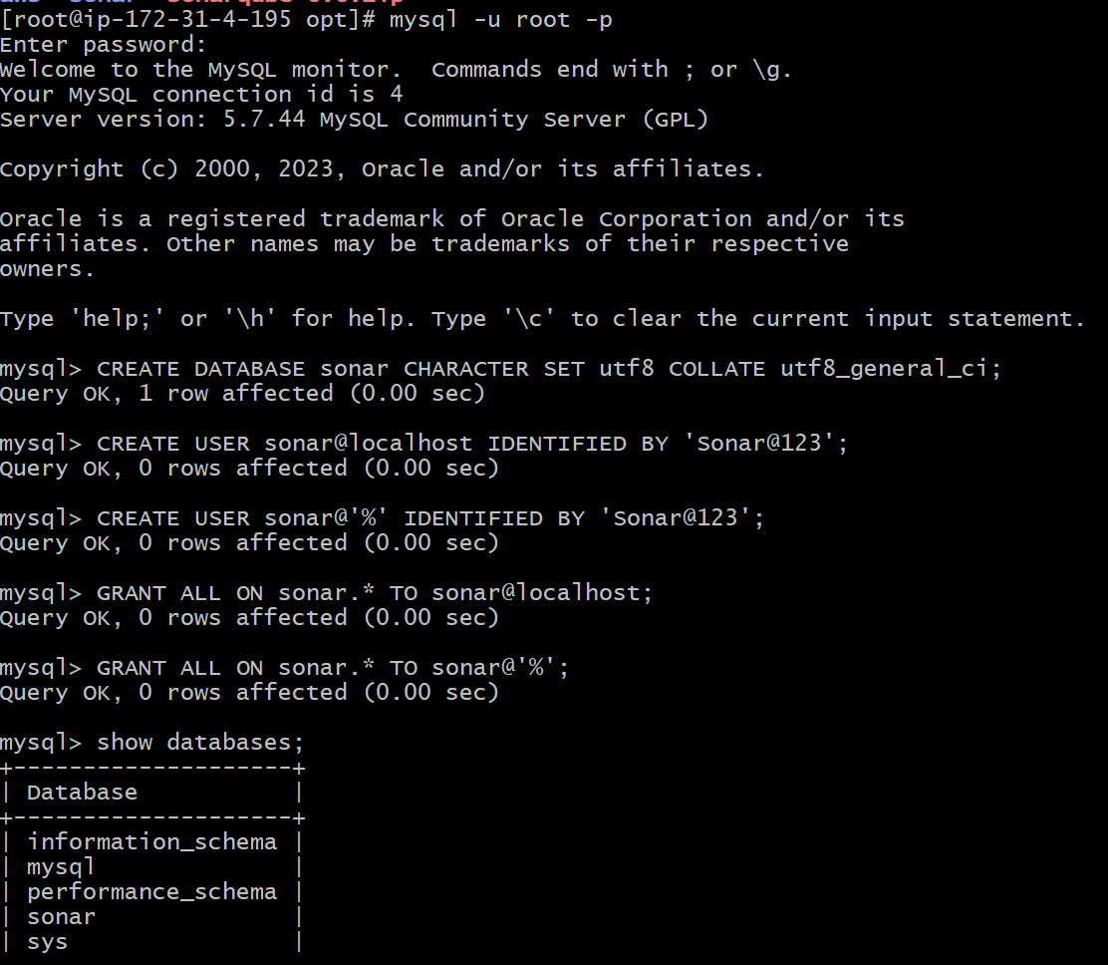
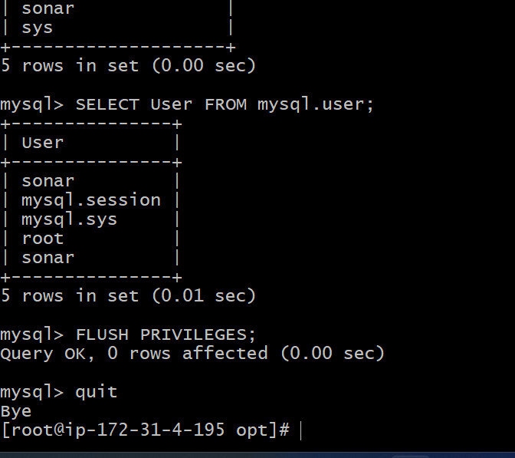
So for you have configured required database information on mysql. Let’s Jump back to your EC2 instance and enable SonarQube properties file to connect his Database.

ON EC2 Instance
Edit sonar properties file to uncomment and provide required information for below properties.
- File Name: /opt/sonar/conf/sonar.properties
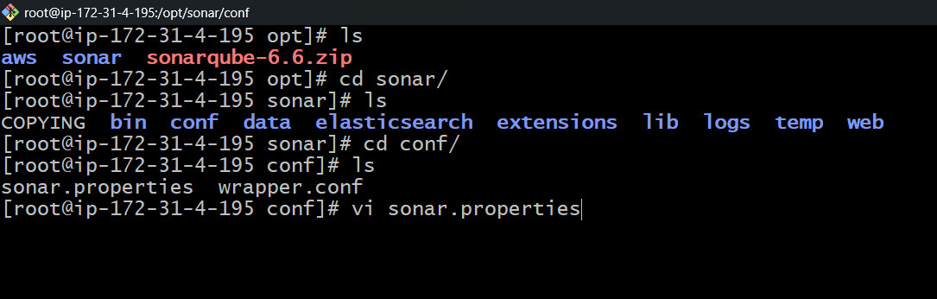
- sonar.jdbc.username=`sonar`
- sonar.jdbc.password=`Sonar@123`
-sonar.jdbc.url=jdbc:mysql://`localhost:3306`/sonar?useUnicode=true&characterEncoding=utf8&rewriteBatchedStatements=true&useConfigs=maxPerformance&useSSL=false
- sonar.web.host=`0.0.0.0`
- sonar.web.context=`/sonar`
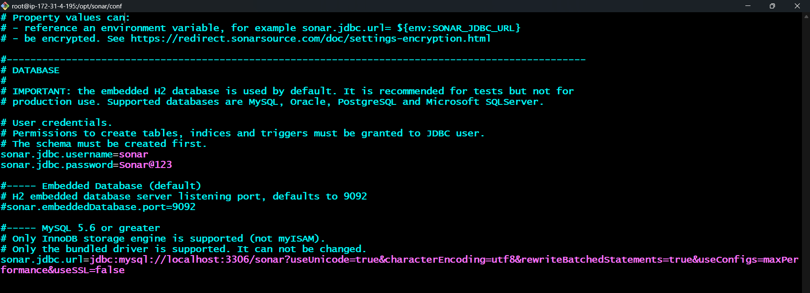
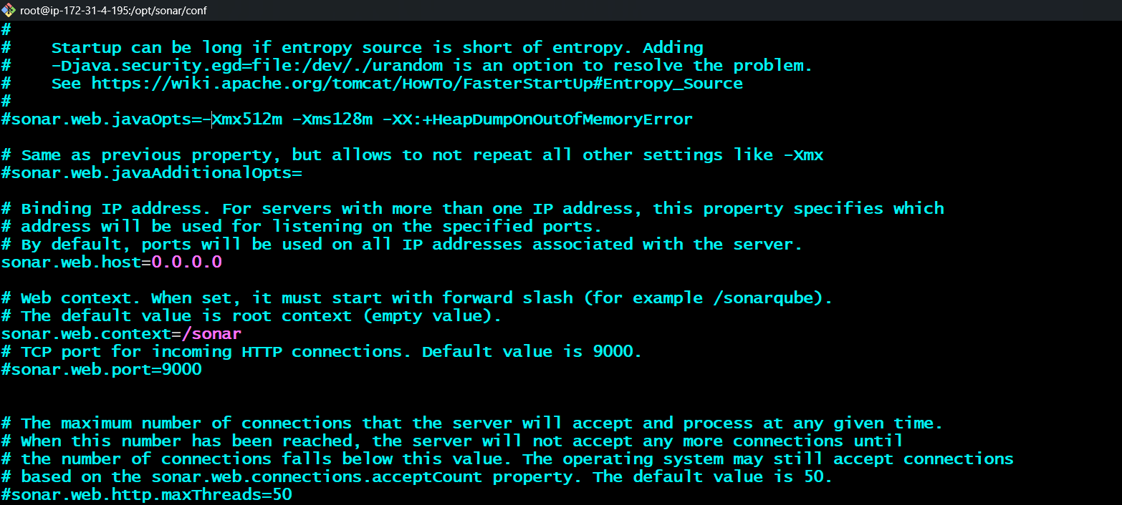

Switch to newly created user [ec2-user]
# sudo su ec2-user
Start SonarQube service
# cd /opt/sonar/bin/linux-x86-64/
# ./sonar.sh start

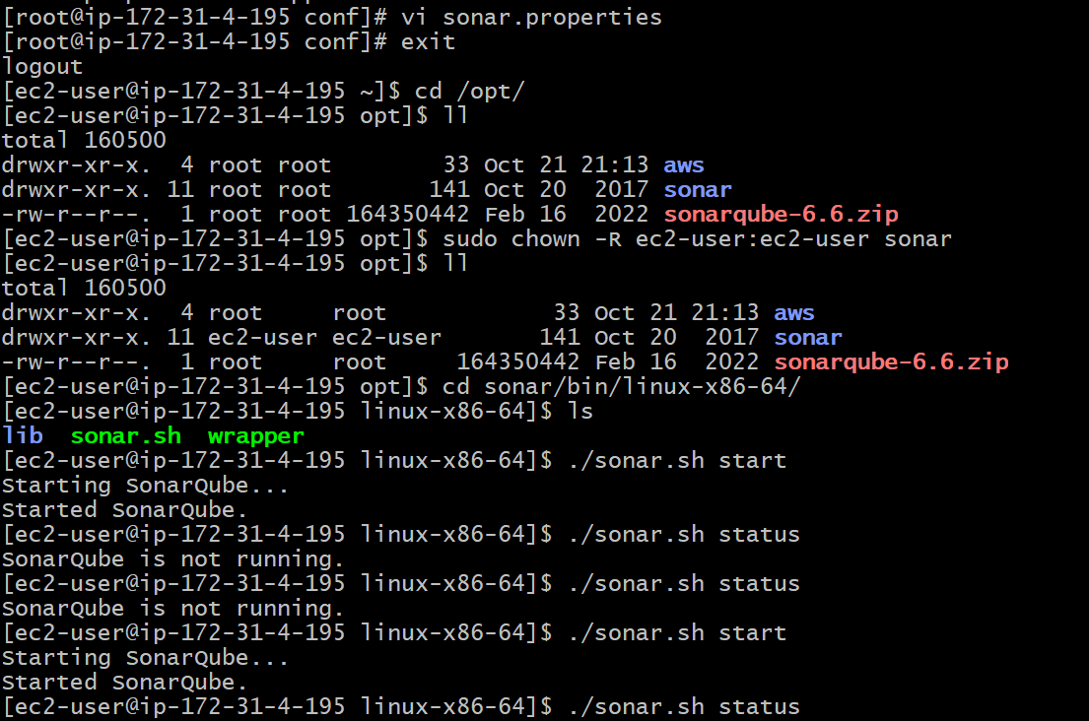
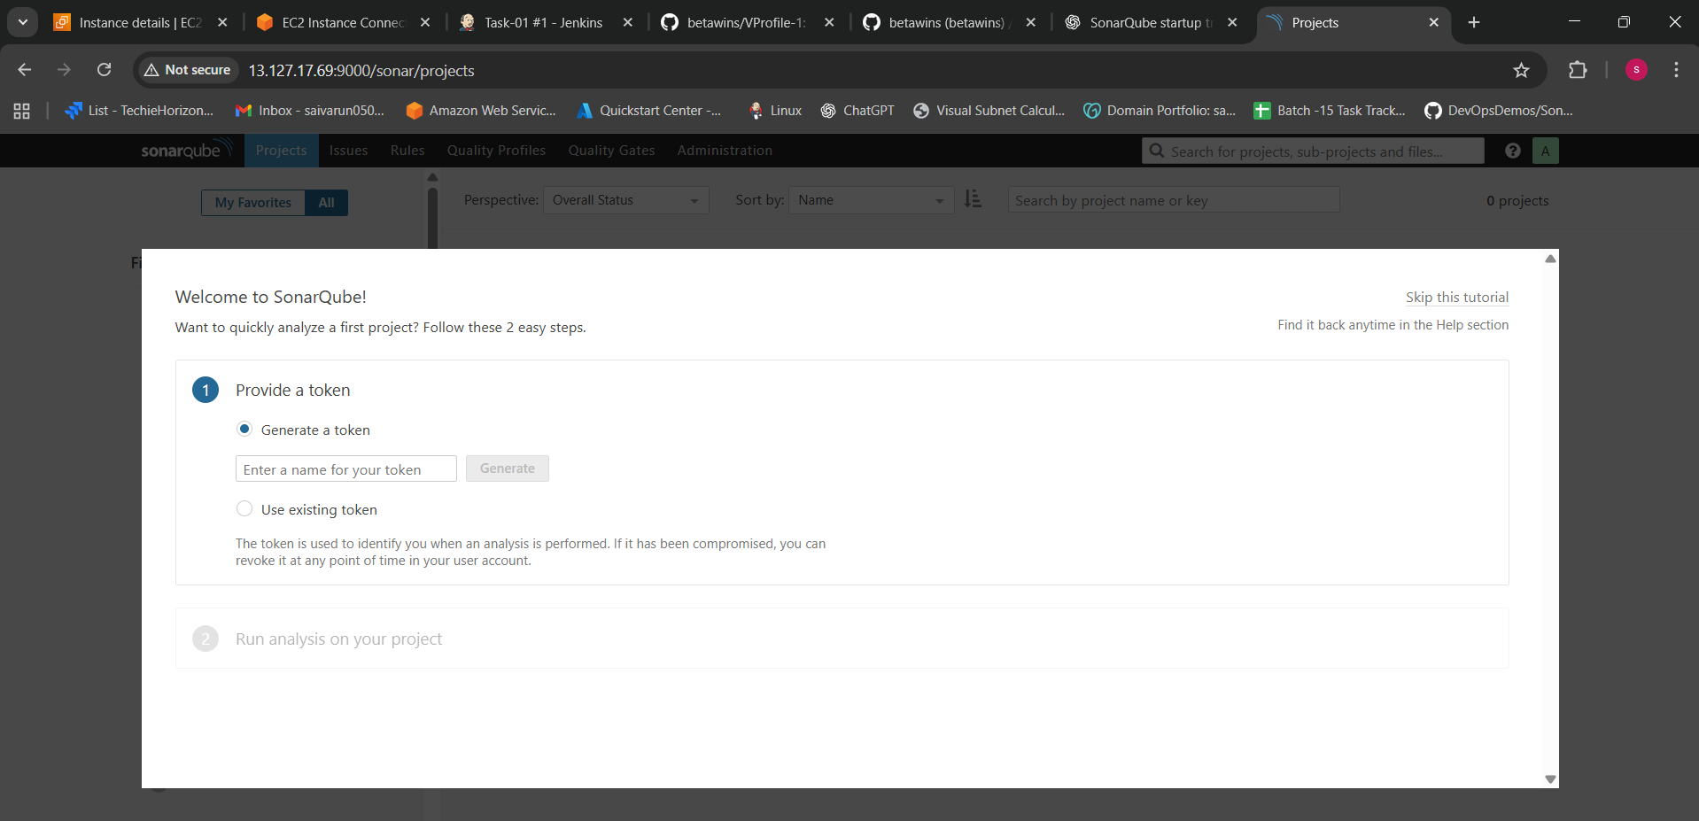
http://3.110.165.185:9000/sonar - Path for sonarQube
User:-admin
password:-admin
Now add sonarqube scanner plugin in your Jenkins.
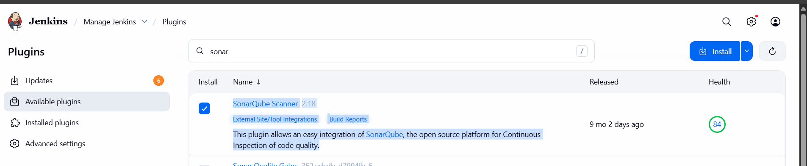
0161e7b337874aa32d0ed1a1349b03686ff58a8d
Generate a key in sonarqube.
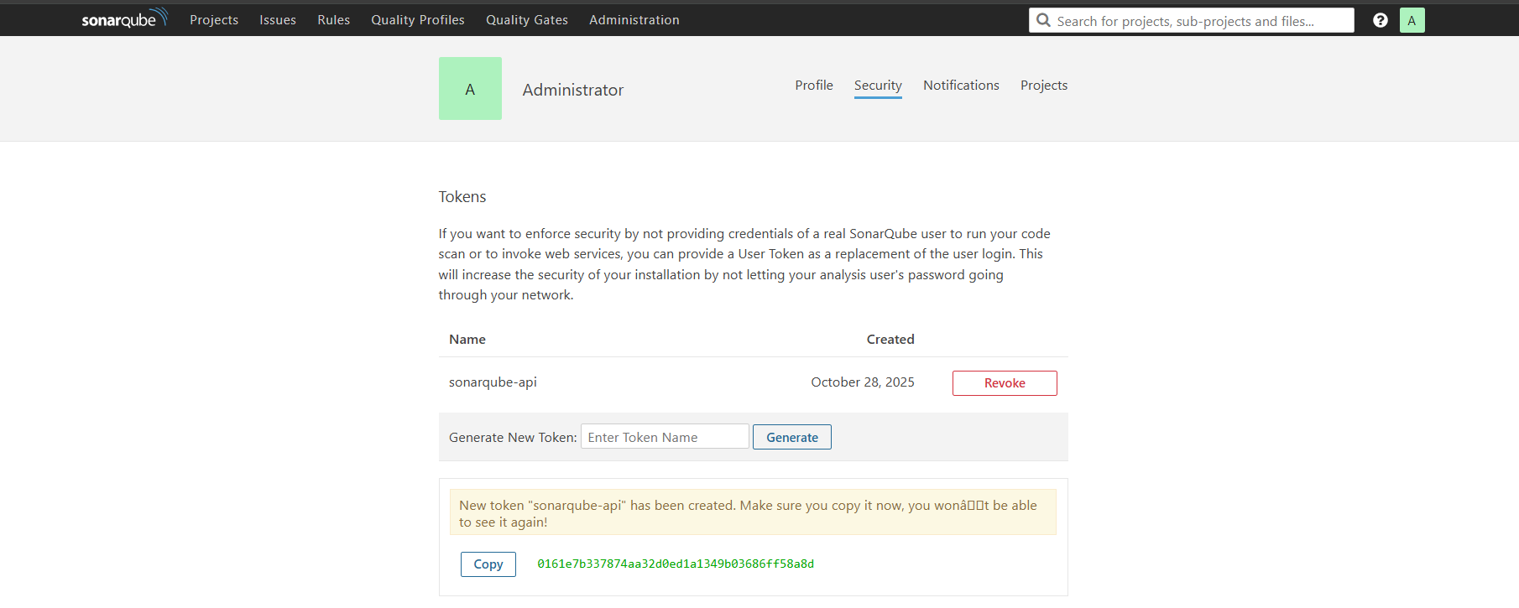
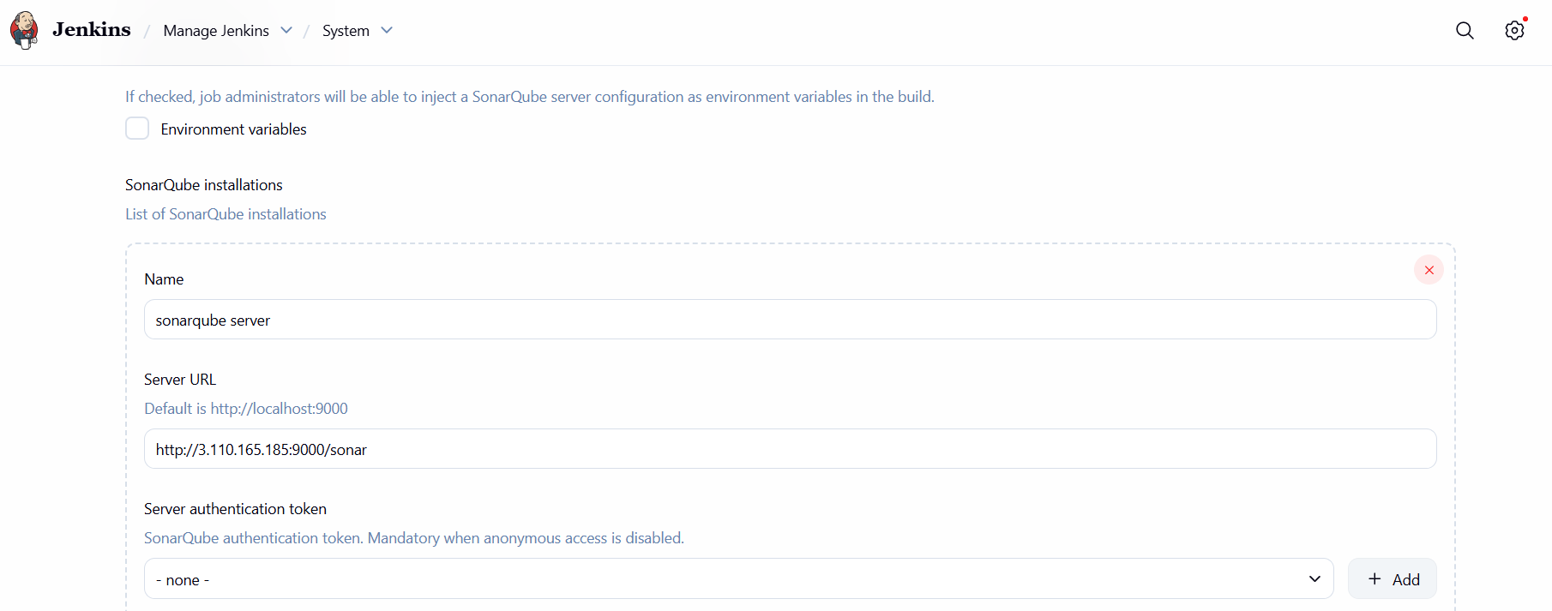
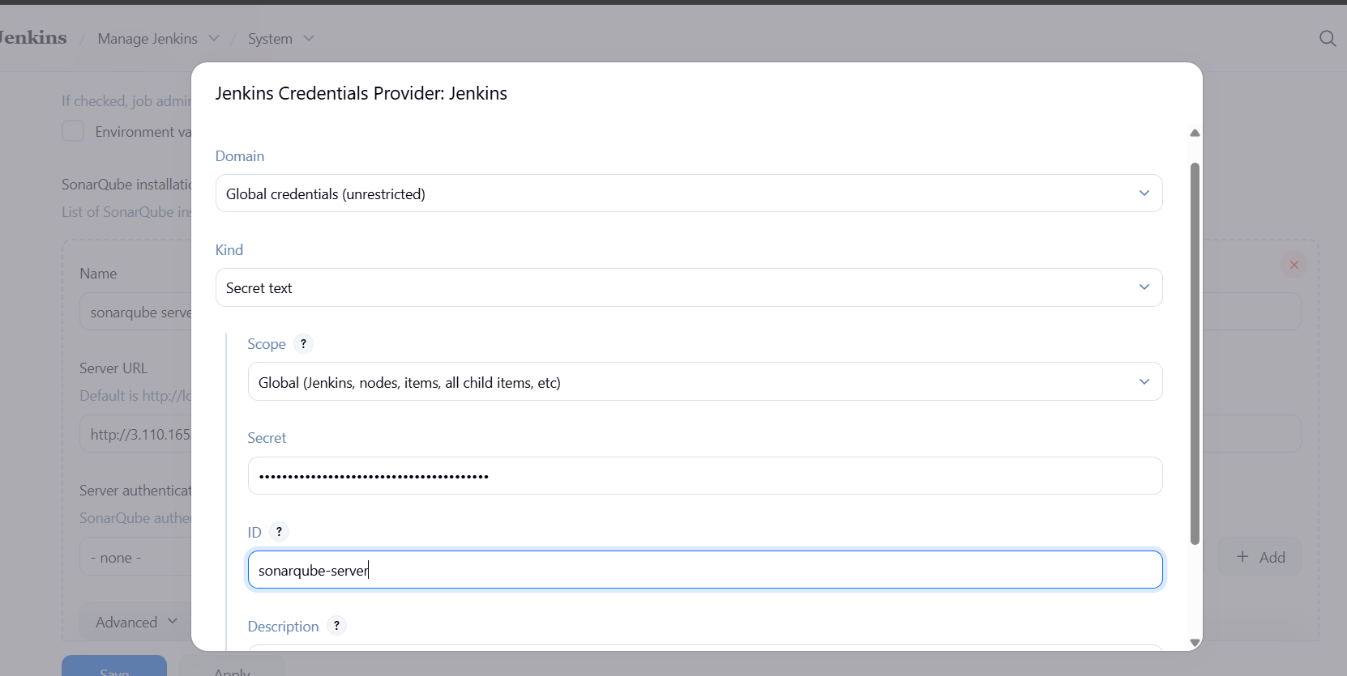
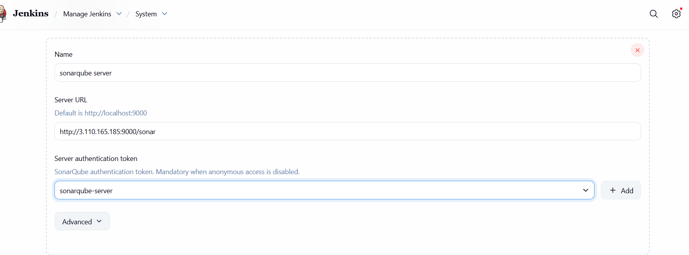
Now, sonar integration with Jenkins:-

Go to Jenkins and install sonar scanner

wget https://binaries.sonarsource.com/Distribution/sonar-scanner-cli/sonar-scanner-cli-4.6.2.2472-linux.zip
unzip sonar-scanner-cli-4.6.2.2472-linux.zip
mv sonar-scanner-4.6.2.2472-linux /opt/sonar_scanner
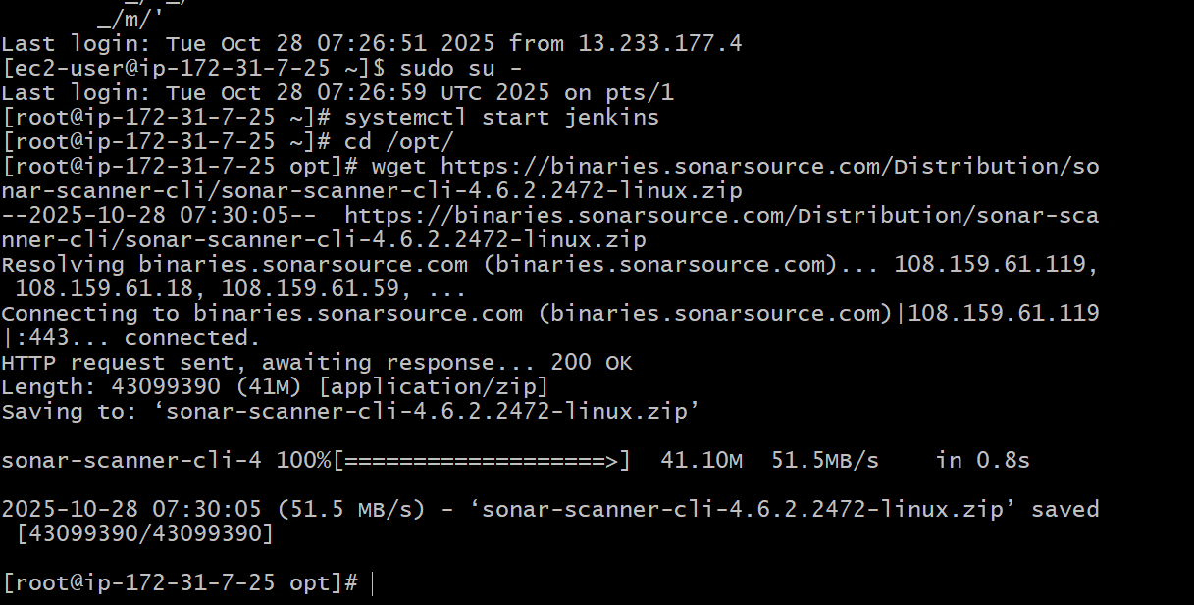
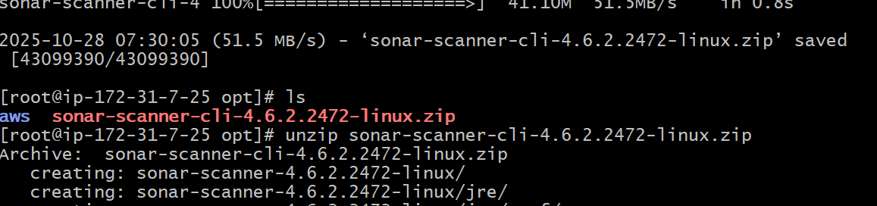
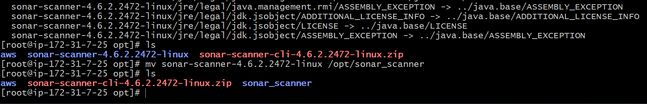
Set SonarQube server details in sonar-scanner property file
Sonar properties file: /opt/sonar_scanner/conf/sonar-scanner.properties
sonar.host.url=http://`<SONAR_SERVER_IP>`:9000
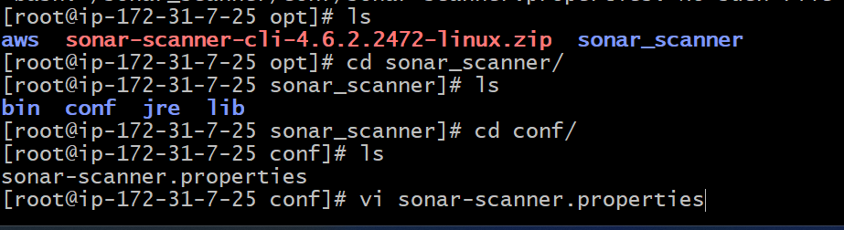
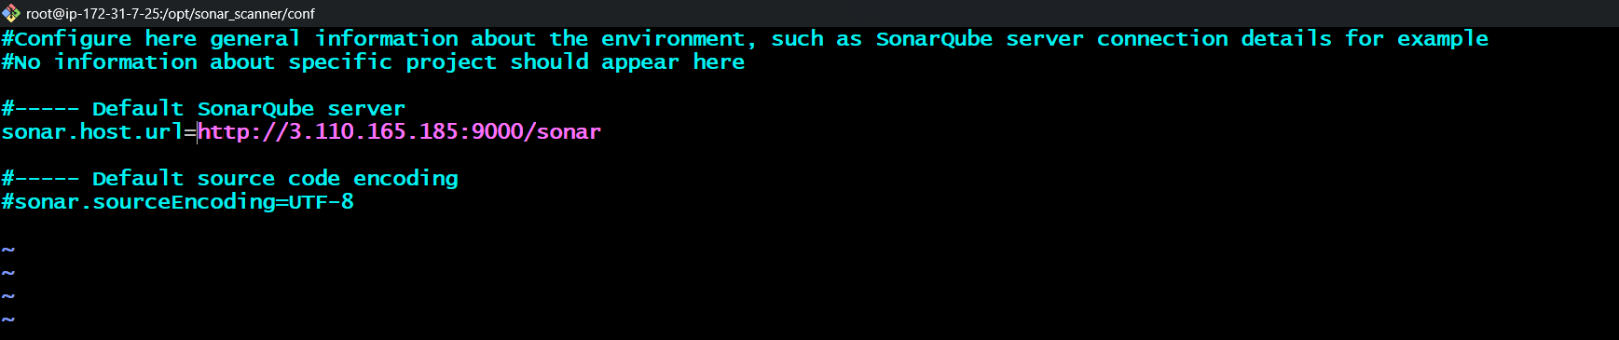
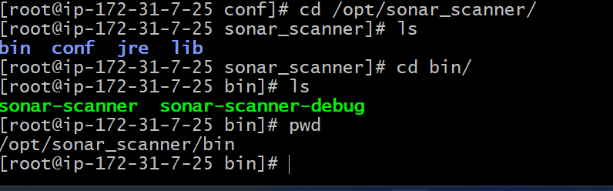
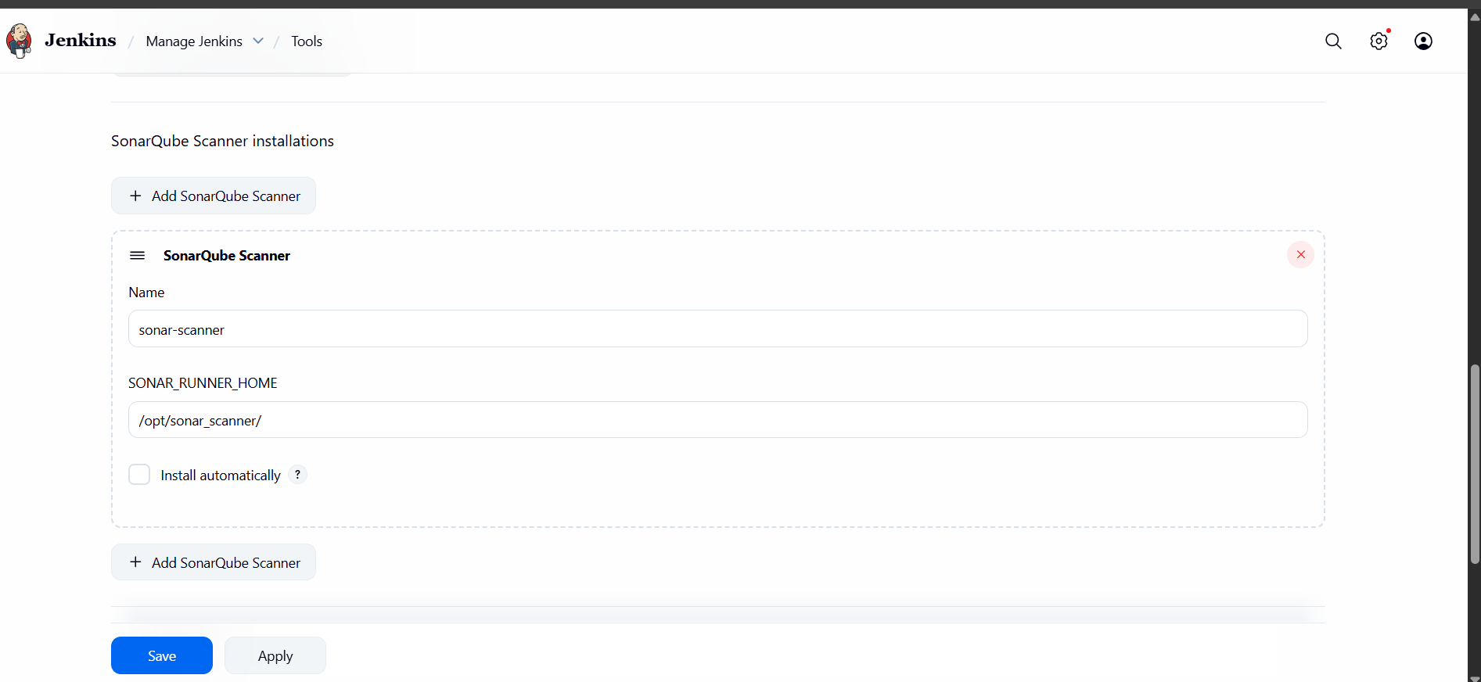

sonar.projectKey=Sabear
sonar.projectName=Sabear
sonar.projectVersion=1.0
sonar.sources=/var/lib/jenkins/workspace/$JOB_NAME/src/
sonar.binaries=target/classes/com/visualpathit/account/controller/
sonar.junit.reportsPath=target/surefire-reports
sonar.jacoco.reportPath=target/jacoco.exec
sonar.java.binaries=src/main/java/com/visualpathit/account/
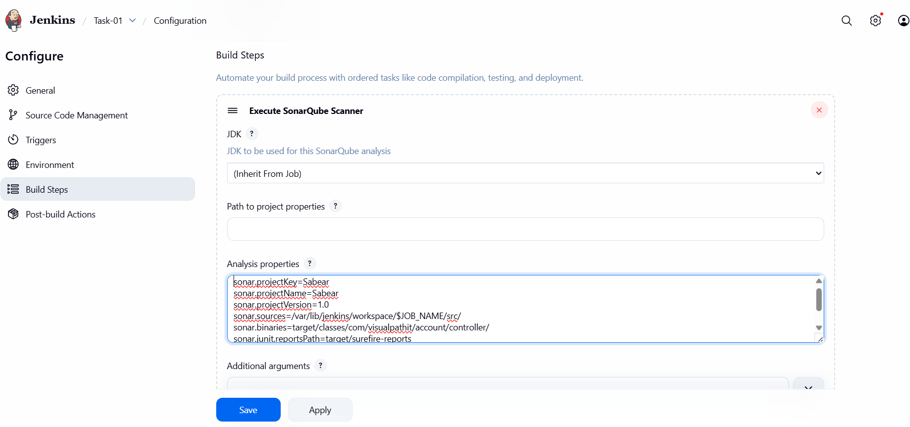
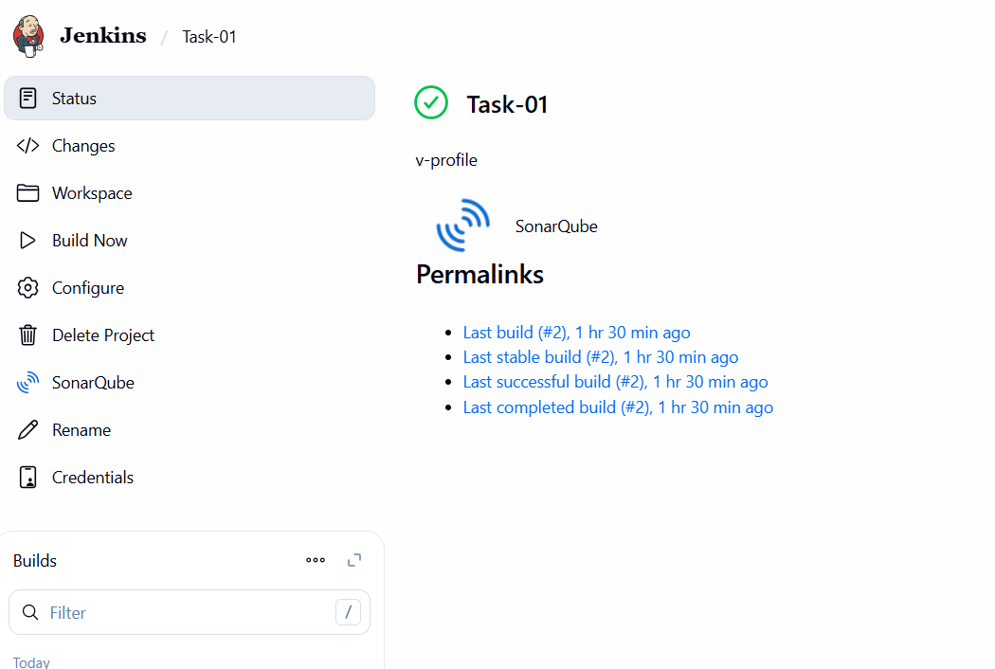
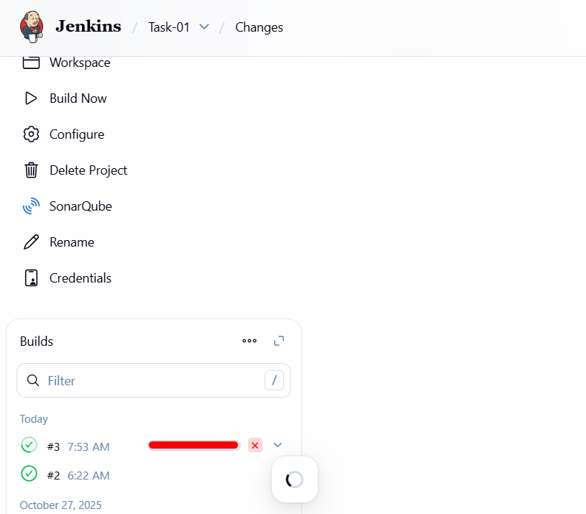
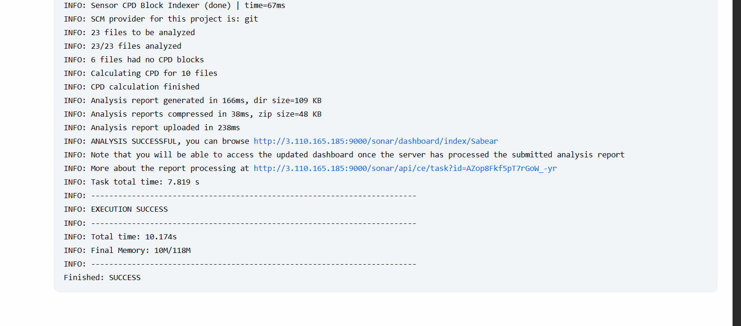

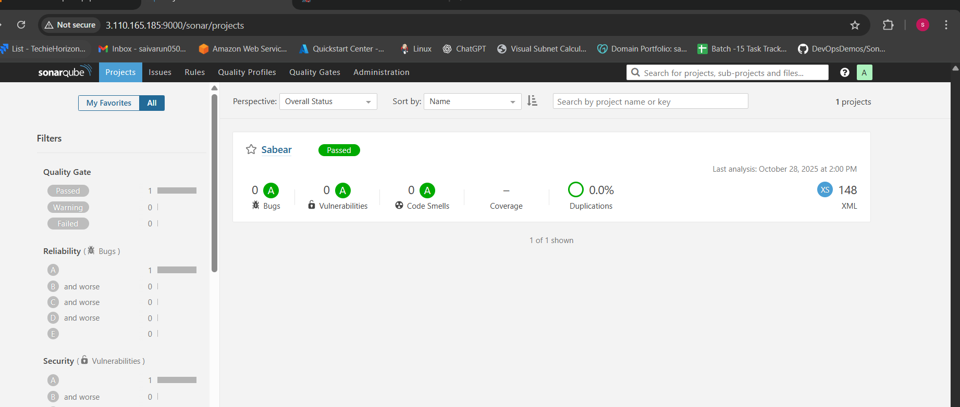

-------------------------------------------------------------------------------------------------------------------------------------

Task 2
Create one Jenkins job using the below code and create three stages:
- stage1: Git clone to download the source code.
- stage2: Sonarqube Integration to check the quality of code.
- stage3: Slack Integration to send the alerts to slack.
URL: https://github.com/betawins/hiring-app.git
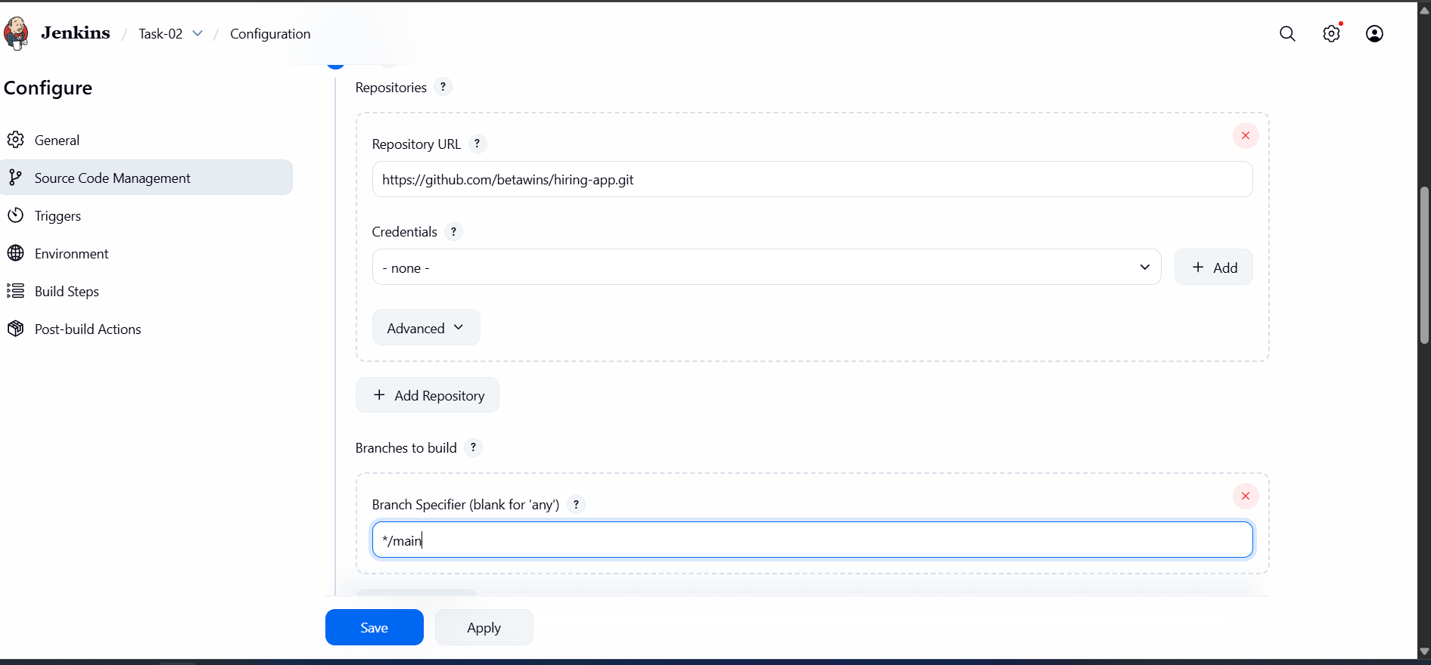
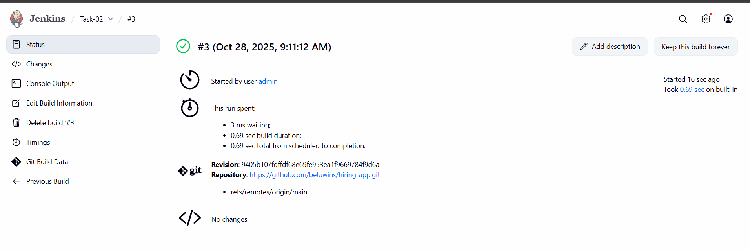
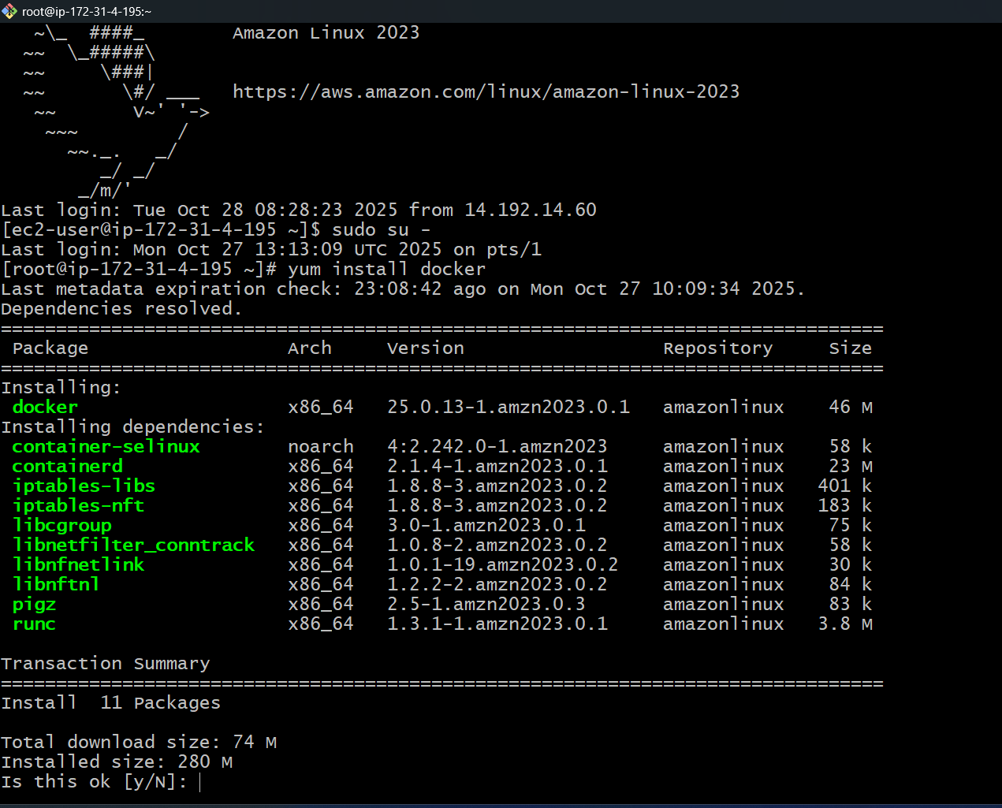
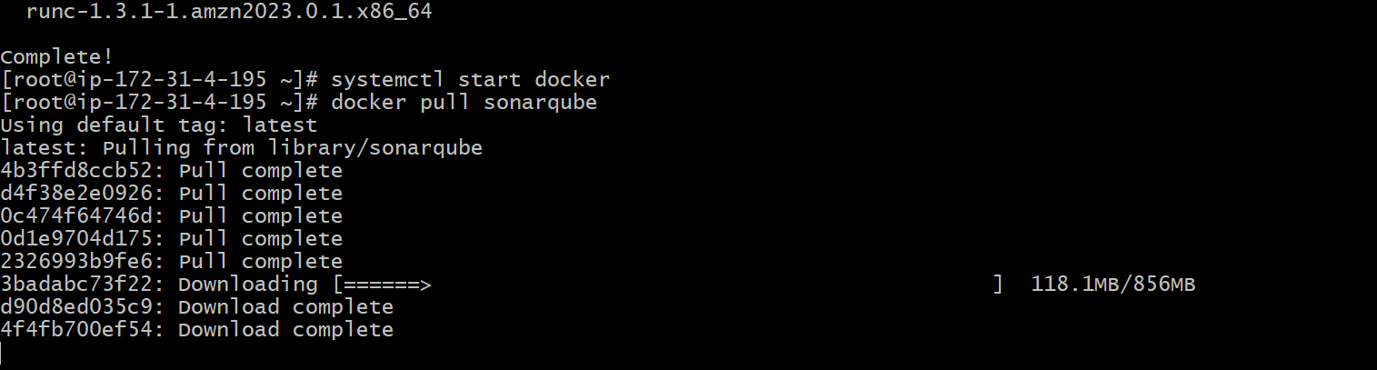
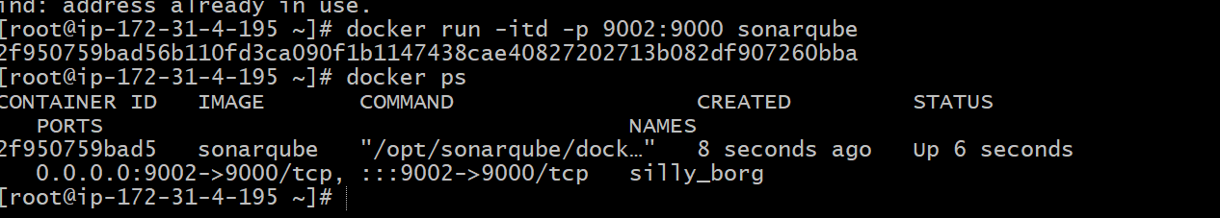
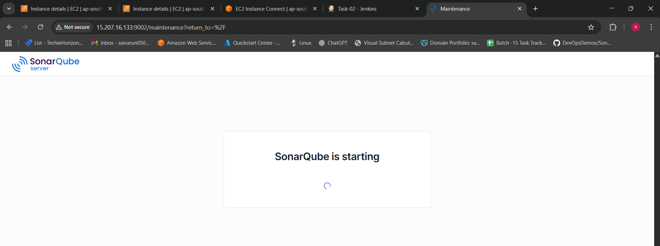

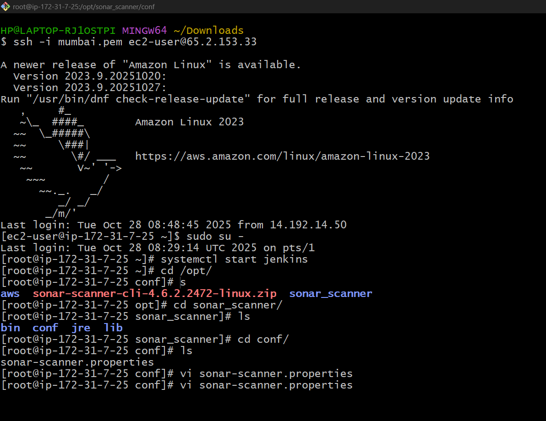
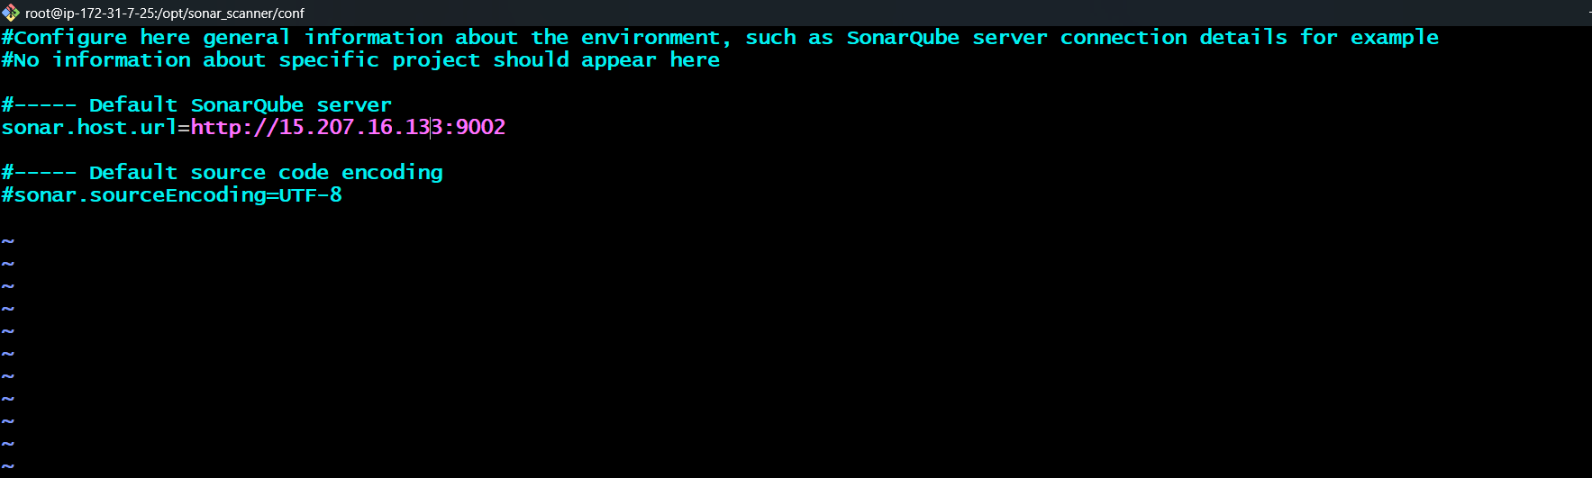
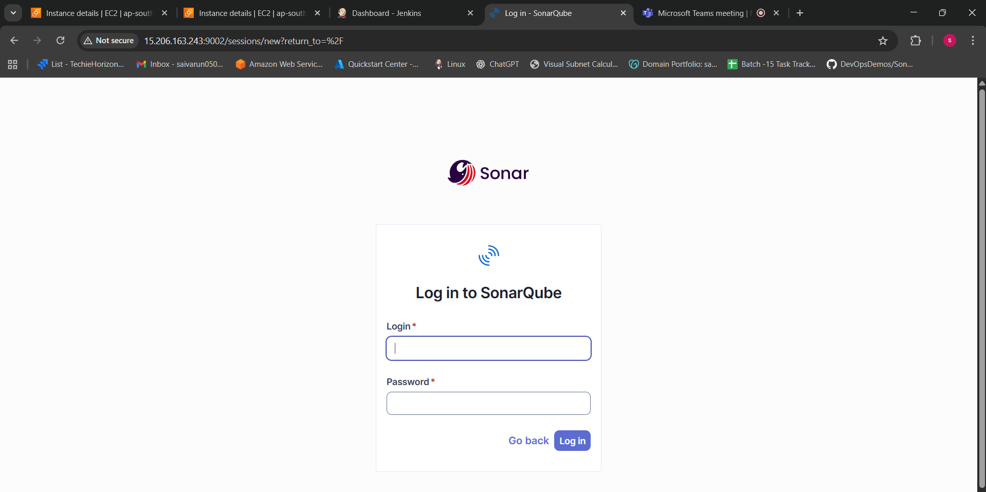

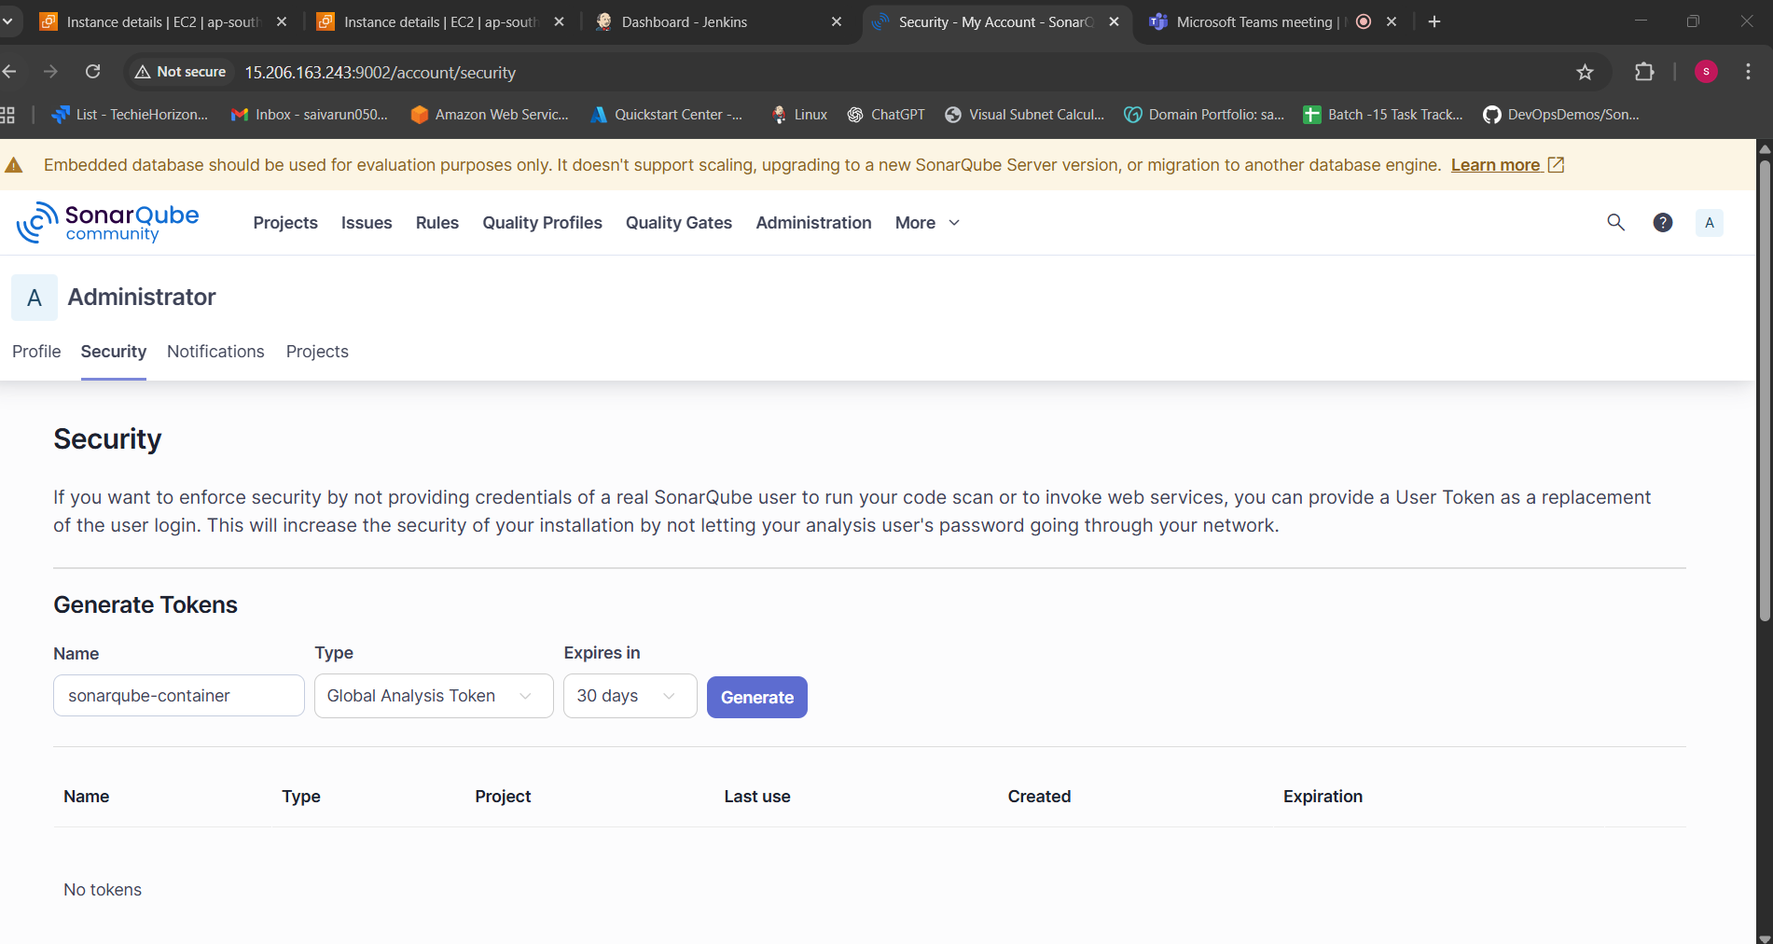
sqa_425c3a86a7340b78854645373a82452e514074e9
